CYBERSECURITY TOOLS · WEEKLY LEARNING TRACK
Nmap Reference Documentation
Module 7 — Output Formats & Reporting

Prepared by Emmanuel Aidoo
Kali Linux · Nmap 7.98
September 22, 2026

Contents
1 Normal Output (-oN) 3
2 Grepable Output (-oG) 4
3 XML Output (-oX) 5
4 All Formats At Once (-oA) 6
5 Key Takeaways 7

Objective: understand Nmap's file output formats and what each is actually for, beyond just “saving the scan.”
Topic: human-readable output (-oN), grepable output (-oG), XML output (-oX), and all three at once (-oA). All scans below target 173.230.138.70.

1 Normal Output (-oN)
● ● ●
$ nmap -oN normal_output 173.230.138.70
What I learned
-oN saves exactly what Nmap prints to the screen into a file, formatting and all. It's the simplest output option: nothing changes about the content, only where it ends up.
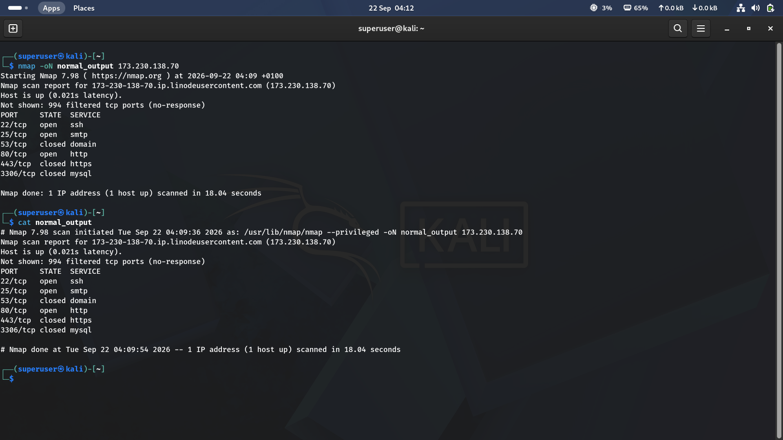
Figure 1 · Normal-format output saved to a file, then displayed again with cat
Result summary
Port | State | Service
22/tcp | open | ssh
25/tcp | open | smtp
53/tcp | closed | domain
80/tcp | open | http
443/tcp | closed | https
3306/tcp | closed | mysql

My observation
Running cat on normal_output reproduced the terminal output line for line — same host block, same port table, same closing summary. That's the whole point of -oN: a plain-text record for a person to read later, not a format built for another program to parse.

2 Grepable Output (-oG)
● ● ●
$ nmap -oG grepable_output 173.230.138.70
What I learned
-oG rewrites the entire scan onto just a few dense lines, one per host, designed to be filtered with tools like grep, awk, or cut rather than read directly. Every host, port, and state gets packed into a single predictable line format.
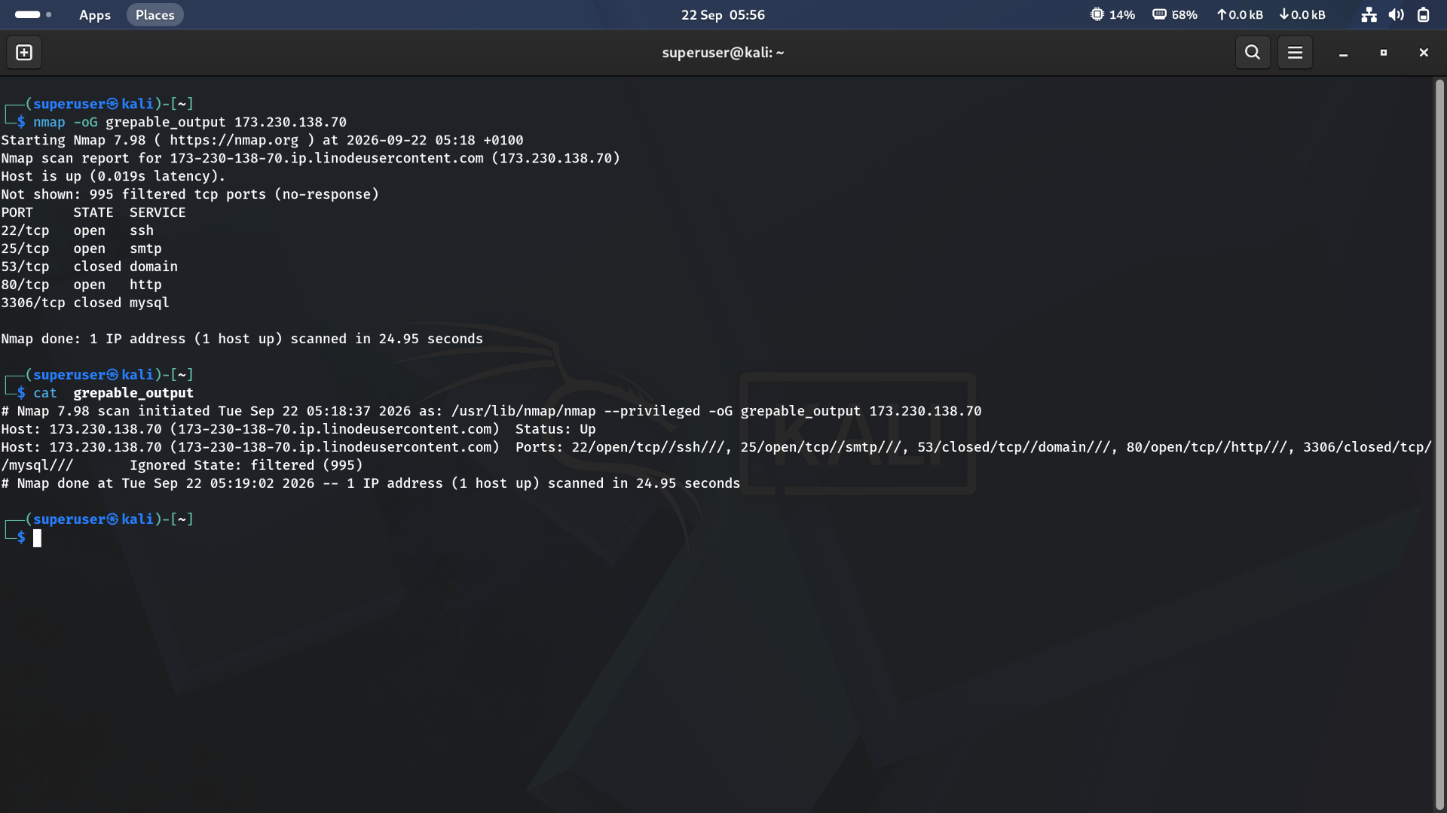
Figure 2 · Grepable-format output, one dense line per host instead of a table
Result summary
Port | State | Service
22/tcp | open | ssh
25/tcp | open | smtp
53/tcp | closed | domain
80/tcp | open | http
3306/tcp | closed | mysql

My observation
One line stated the host and its status (“Host: 173.230.138.70 ... Status: Up”), and a second packed every port into a comma-separated list: “22/open/tcp//ssh///, 25/open/tcp//smtp///, 53/closed/tcp//domain///...”, ending with “Ignored State: filtered (995)”. That structure is exactly why it's called grepable: a single grep for “/open/” against this file would list every open port on every host in a scan, no parsing required.

3 XML Output (-oX)
● ● ●
$ nmap -oX XML_output 173.230.138.70
What I learned
-oX produces a structured XML document instead of plain text — the format most other tools (report generators, vulnerability scanners, custom scripts) expect when they consume Nmap results programmatically.
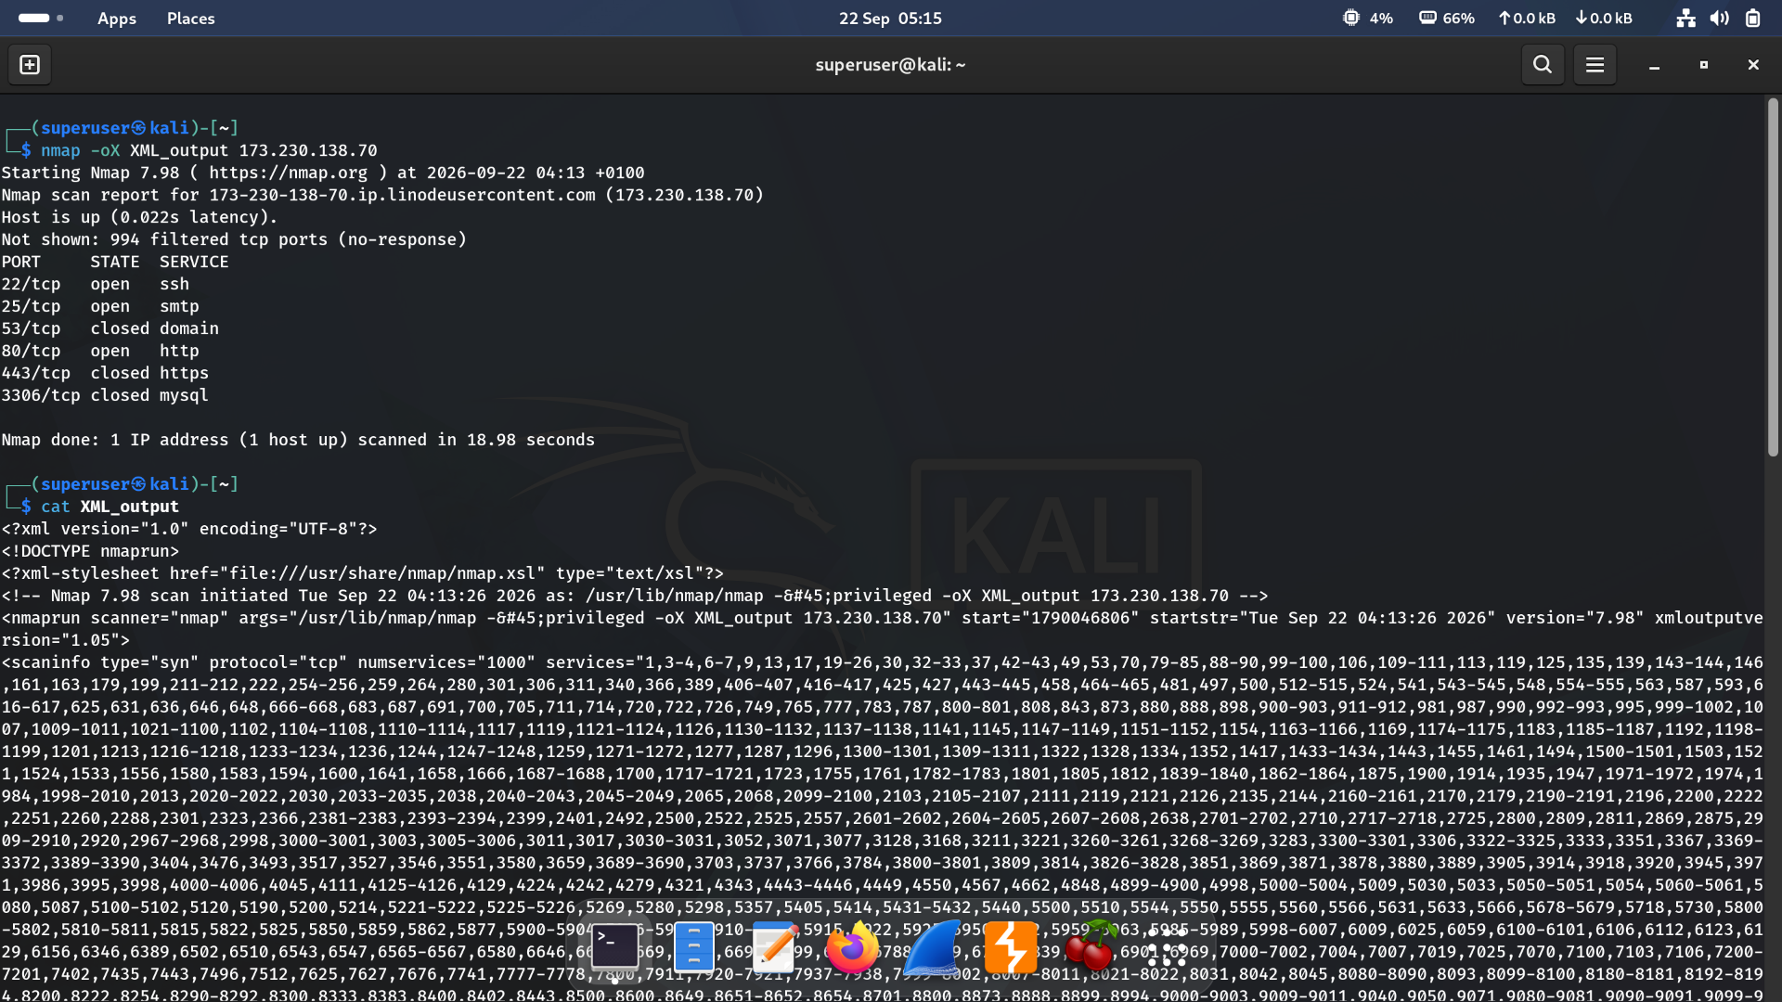
Figure 3 · XML-format output, including the scan's full metadata and port list
Result summary
Element | Purpose
<?xml-stylesheet ...?> | Points to Nmap's own XSL stylesheet, so the file can render as a formatted report when opened directly in a browser
<nmaprun scanner, args, start, version> | Records the exact command line, start time, and Nmap version used, information the plain-text formats don't capture explicitly
<scaninfo type="syn" numservices="1000"> | Documents scan type and the full list of scanned ports/services as structured attributes, not just a human-readable summary

My observation
Every other format in this module is built for a human or a text-processing tool to read. XML is built for a program to parse reliably: consistent tags, explicit attributes, and no ambiguity about where one field ends and another begins. This is the format tools like Metasploit's importer or custom Python scripts reach for when they need to work with scan results directly.

4 All Formats At Once (-oA)
● ● ●
$ nmap -oA All_output 173.230.138.70
What I learned
-oA writes normal, XML, and grepable output simultaneously, all sharing one base filename with three different extensions. It's the practical default for any scan worth keeping, since it costs nothing extra to have all three on hand.
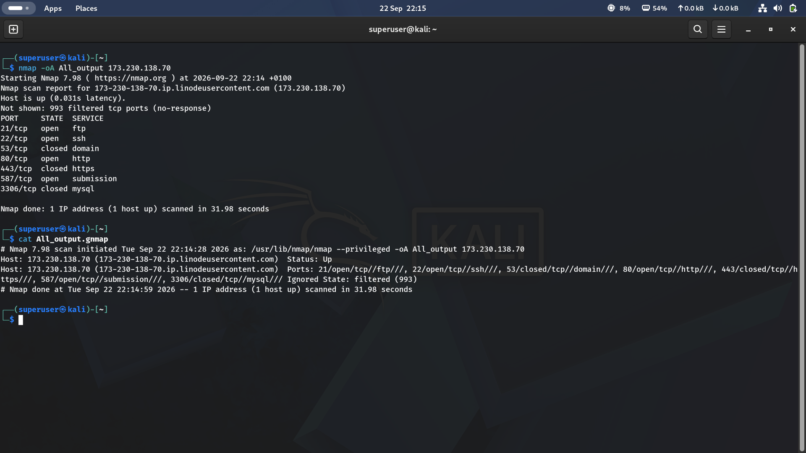
Figure 4 · A single scan producing All_output.nmap, All_output.xml, and All_output.gnmap together
Result summary
Port | State | Service
21/tcp | open | ftp
22/tcp | open | ssh
53/tcp | closed | domain
80/tcp | open | http
443/tcp | closed | https
587/tcp | open | submission
3306/tcp | closed | mysql

My observation
This scan turned up port 21 (ftp) open, something none of the earlier scans in this module saw, and dropped port 25 (smtp), which had been open in the previous two runs. Every -oA/-oN/-oG/-oX scan in this module targeted the same host, run only hours apart, yet returned different sets of open ports each time. That's a strong reminder that a single scan is a snapshot, not a permanent profile of a host, services genuinely start and stop, and a report generated once can go stale quickly.

5 Key Takeaways
- -oN saves the exact human-readable output to a file — same content as the terminal, just persisted for later reading.
- -oG packs each host onto a dense, single-line record built for grep, awk, and similar text-filtering tools, not for a person to read directly.
- -oX produces structured XML with explicit metadata (command line, scan type, timestamps) that other tools can parse reliably — the right choice for feeding results into another program.
- -oA writes all three formats from one scan at essentially no extra cost, which makes it a sensible default whenever a scan is worth keeping at all.
- The same host returned different open ports across every scan in this module — a reminder to treat any single scan report as a snapshot in time, not a fixed description of a host.

